Password Cracking Challenge Using John the Ripper
Introduction
In the evolving landscape of cybersecurity, the integrity of authentication mechanisms—particularly password-based systems—remains a cornerstone of defense against unauthorized access. Despite advancements in multi-factor authentication and biometric verification, passwords persist as a ubiquitous form of security across digital platforms. Consequently, understanding the vulnerabilities associated with weak password practices is not merely an academic exercise but a practical necessity for aspiring cybersecurity professionals. This project, a Password Cracking Challenge utilizing the powerful and versatile tool John the Ripper, is designed to provide hands-on experience in offensive security techniques within a controlled and ethical environment. The primary objective is to demonstrate how easily poorly chosen passwords can be compromised using common attack methodologies, thereby illuminating the critical importance of robust password policies and advanced cryptographic defences.
The project begins with the creation of a custom set of password hashes, simulating a scenario where an attacker has obtained a database of encrypted credentials. Participants will generate hashes using the MD5 algorithm, a historically prevalent but now widely deprecated mechanism due to its vulnerability to rapid cracking. John the Ripper, a pre-installed tool in the Kali Linux distribution, will then be employed to execute both dictionary and brute-force attacks against these hashes. Through this process, the stark contrast between the resilience of complex passwords and the susceptibility of simplistic ones becomes empirically evident. The exercise not only reinforces theoretical knowledge of cryptographic principles but also offers tangible insights into the real-world tactics used by malicious actors.
Moreover, this challenge extends beyond mere technical execution to encompass analytical and defensive perspectives. Participants will evaluate the effectiveness of various password compositions, assess the impact of hashing algorithms on security, and formulate evidence-based recommendations for enhancing organizational password policies. By bridging the gap between offensive action and defensive strategy, the project cultivates a holistic understanding of identity and access management. It underscores the imperative of continuous learning and adaptation in cybersecurity, where defensive measures must constantly evolve to counter increasingly sophisticated threats. Ultimately, this endeavor aims to empower interns with the practical skills and critical mindset needed to contribute meaningfully to the protection of digital assets in any professional setting.

Abstract
This project demonstrates the practical application of password cracking techniques using John the Ripper, a powerful and widely used open-source password recovery tool. The core activity involves generating a set of password hashes using the MD5 algorithm and subsequently attempting to crack them through both dictionary and brute-force attacks. The process includes using pre-existing wordlists, such as rockyou.txt, to efficiently decipher weakly constructed passwords, while also highlighting the computational infeasibility of cracking complex, well-structured passwords within a reasonable timeframe. The project is conducted within the Kali Linux environment, leveraging its built-in cybersecurity tools to simulate a real-world attack scenario in a controlled and ethical manner.
The significance of this project lies in its ability to translate abstract security concepts into tangible, observable outcomes. By visually demonstrating how quickly simple passwords can be compromised, it underscores the critical importance of strong password policies in safeguarding user accounts and sensitive systems. Furthermore, the project serves as an essential exercise in understanding offensive security tactics, which is fundamental to developing effective defensive strategies. It emphasizes the necessity of using modern, resilient hashing algorithms—like bcrypt or SHA-512—over outdated and vulnerable ones like MD5. This hands-on experience not only builds technical proficiency in using industry-standard tools but also fosters a deeper appreciation for robust identity and access management practices, making it an invaluable component of practical cybersecurity education.

Tools Used
This project was performed on a dedicated Kali Linux virtual machine, utilizing a suite of pre-installed tools designed for penetration testing and security analysis.
1. Operating System:
Kali Linux:
- A Debian-derived Linux distribution specifically designed for digital forensics and penetration testing. It was chosen for this project because it comes pre-packaged with all the necessary security tools, a streamlined kernel for security workloads, and a configured environment, eliminating setup time and compatibility issues.
- Specialized Linux distributions designed for security testing, penetration testing, and digital forensics. They come pre-loaded with hundreds of security tools.
- This is the "attacker" or "tester" machine. It exists in a separate virtual machine on the same virtual network. You use it to scan and attempt to access the Ubuntu server, simulating how a real hacker might probe your system.
- It provides a dedicated, safe, and legal environment to test your firewall rules from an external perspective, ensuring they work correctly against common attack tools.
2. Primary Tool:
- John the Ripper (john): A free, open-source, and incredibly fast password cracking tool. It is the core utility for this project. Its functionality includes:
  - Multiple Attack Modes: It was used in its dictionary attack mode, which is highly efficient against weak passwords.
  - Hash Format Detection: John can auto-detect common hash types, but for this project, the format (Raw-MD5) was explicitly specified for precision.
  - Version: The pre-installed version available in the Kali Linux repositories was used (e.g., john 1.9.0).

3. Supporting Tools & Packages:
OpenSSL:
- A robust, full-featured toolkit for the Transport Layer Security (TLS) and Secure Sockets Layer (SSL) protocols. It also contains a general-purpose cryptography library. In this project, the openssl command-line tool was used to generate the MD5 hashes from plaintext passwords for our test file.
Command: openssl md5
The openssl md5 command is used to compute the MD5 hash digest of a specified file. MD5 is a widely-used cryptographic function that produces a unique 128-bit (16-byte) hash value, typically rendered as a 32-character hexadecimal number.
Wordlists: A critical component for any dictionary-based attack.
- rockyou.txt: A famous wordlist containing over 14 million real passwords compiled from the 2009 RockYou data breach. It is the de facto standard for password cracking practice and was used as the primary wordlist for this project. It is located in the Kali Linux directory /usr/share/wordlists/.
Core Utilities:
- Gunzip (gzip): Used to decompress the rockyou.txt.gz file before it could be used by John the Ripper.
- GNU Bash & Terminal: The standard command-line interface on Kali Linux was used to execute all commands and scripts.
- Text Editor (nano): Used to create and edit the hashes.txt file containing the target password hashes.
4. Libraries (Implicit):
- Hashlib (Python concept): While not directly used via Python in this command-line execution, John the Ripper itself utilizes low-level cryptographic libraries to perform its hashing functions, effectively implementing the same principles as Python's hashlib library for generating comparison hashes at high speed.

Steps Involved in Building the Project
Step 1: Preparation and Environment Setup
1. Launch Kali Linux VM
You are starting the virtual machine (VM) where you will perform the entire password cracking project. A VM is a software-based simulation of a physical computer. In this case, it is running the Kali Linux operating system.
Download the Kali Linux ISO:
- Go to the official Kali Linux Downloads page.
Install Virtualization Software:
- Download and install Oracle VM VirtualBox (free) or VMware Workstation Player (free for personal use).
* Download VirtualBox
* Download VMware Workstation Player
- Why is this important?
  - Safety & Isolation: Kali Linux is a powerful penetration testing toolkit. Running it inside a VM (using software like VirtualBox or VMware) creates a contained, sandboxed environment. This means any tools you run or commands you execute are confined to the virtual machine. They cannot accidentally harm your host computer's operating system (e.g., Windows or macOS) or your personal files.
  - Ethical Practice: It ensures you are working in a legal, controlled lab environment that you own. This is a fundamental rule of ethical hacking.
  - Consistency: The Kali Linux VM provides a standardized, pre-configured environment with all the necessary tools already installed and properly set up.

- How to do it:
  - Open your virtualization software (e.g., Oracle VM VirtualBox, VMware Workstation Player).
  - Select your pre-installed "Kali Linux" virtual machine from the list.
  - Click the "Start" button.
  - Log into the Kali Linux system using your username and password.
  - Once the desktop loads, open a terminal window. This is your command-line interface to interact with the system.
Configure VM Networking (Crucial Step):
In your VM software's settings for the Kali machine, set the Network Adapter to "Bridged Adapter". Why Bridged Mode? This gives your Kali VM its own unique IP address on your local network, making it appear as a separate physical machine. This is essential so your host computer can scan it with Nmap and ping to test the firewall rules.
Start the VM and Take a Snapshot:
Boot up the Kali Linux virtual machine. The default credentials are usually kali / kali. Your environment is now ready. You have a dedicated, safe, and updated Kali Linux machine where you can practice configuring ufw and iptables without any risk to your main computer.
2. Update the System
In the terminal window you just opened, type the following command and press Enter:
Command: sudo apt update
- Purpose: Synchronizes the local list of available software packages with the online repositories.
- Function: This command checks for updates but does not install any software. It ensures the system has the latest information on package versions and dependencies before proceeding with an upgrade.

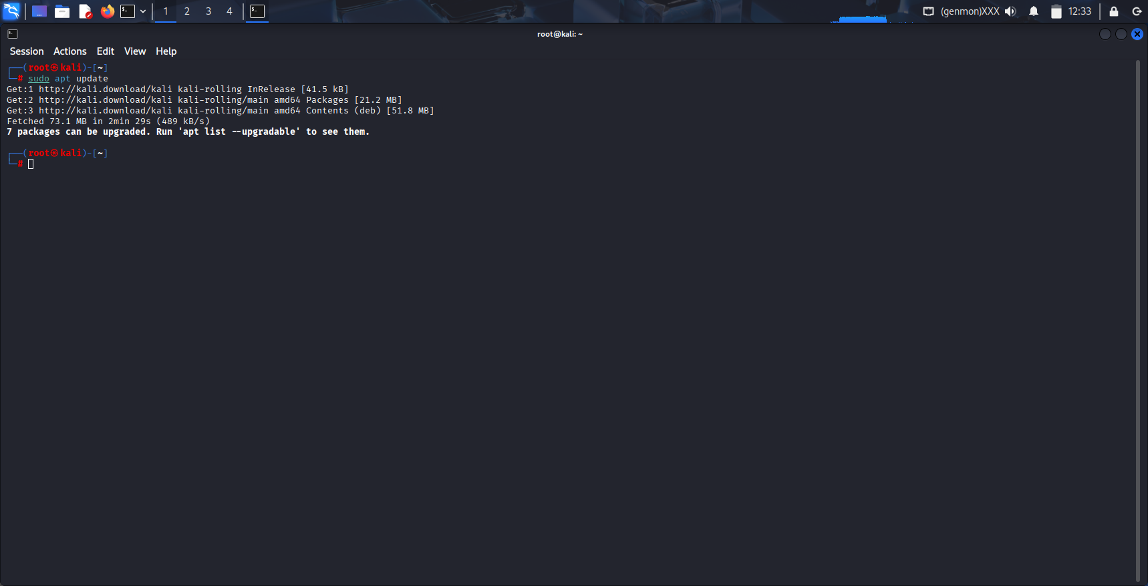
Fig. 1: Executing apt update on Kali Linux
Step 2: Create the Target Password Hash File
This step is the foundational setup for the entire cracking exercise. You are creating the "target" that John the Ripper will later attack. Instead of targeting a real system, you are ethically generating your own file of password hashes to crack.
Part 1: Unzip the Wordlist
You are decompressing the rockyou.txt.gz file to get the actual text-based wordlist, rockyou.txt.
- The Tool: gunzip is a command used to decompress files that were compressed with the Gzip utility.
- The Wordlist: The rockyou.txt wordlist is a famous file containing over 14 million real passwords that were leaked from a company called RockYou in 2009. It is the most common wordlist used for password cracking practice because it contains real-world examples of weak passwords that people actually use.
- Access: John the Ripper cannot read the compressed (.gz) file. It needs the decompressed text file (rockyou.txt) to read the list of words. This file is stored in a system directory (/usr/share/wordlists/), so you need sudo to access and unzip it.
- In your terminal, run:
Command: sudo gunzip /usr/share/wordlists/rockyou.txt.gz
This command decompresses the RockYou password wordlist. It uses sudo to get the needed permissions and gunzip to unzip the file. The final wordlist will be created at /usr/share/wordlists/rockyou.txt.

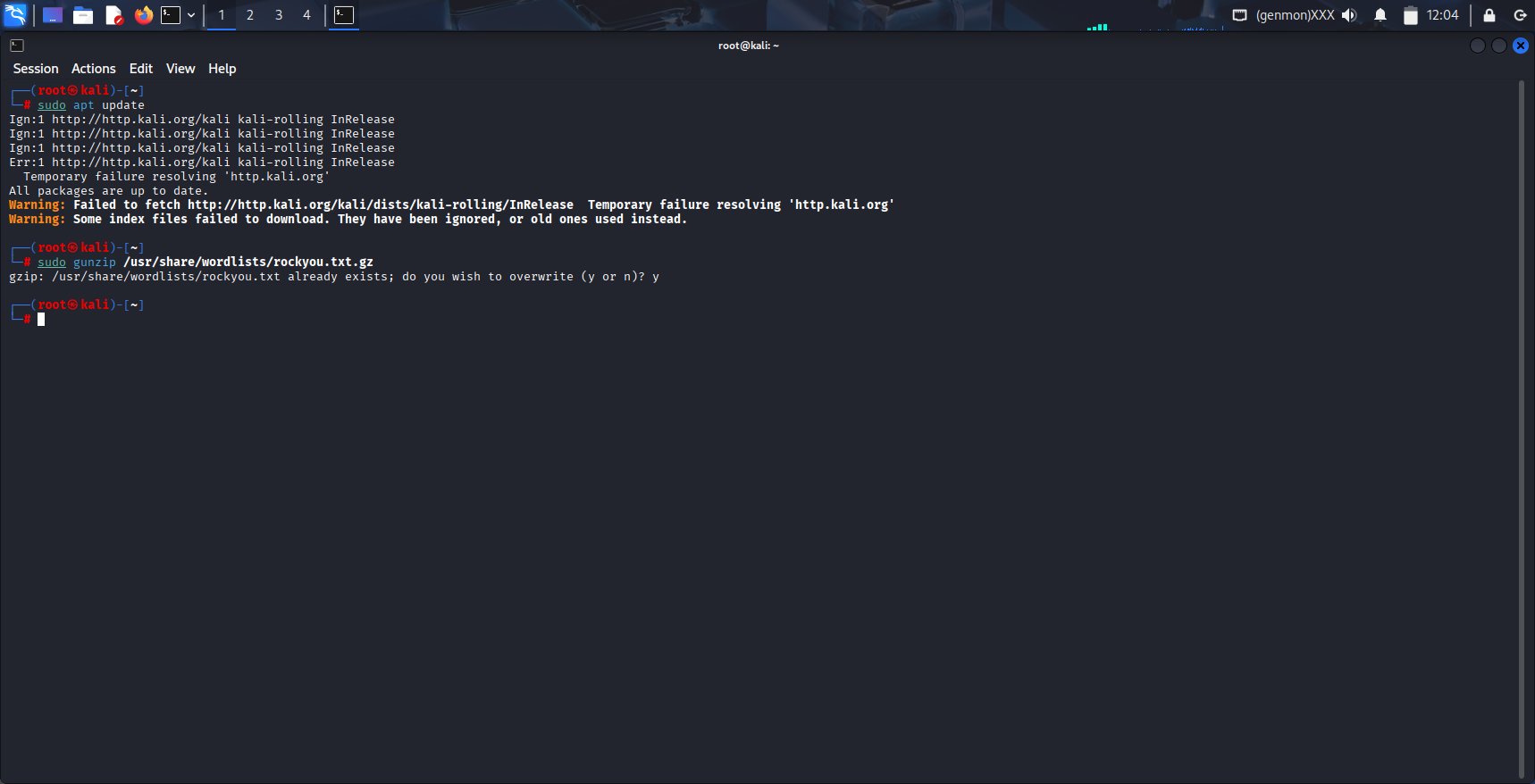
Fig. 2: sudo gunzip /usr/share/wordlists/rockyou.txt.gz to decompress the file
This command will decompress the file. There is no visible output if it's successful. You can now find the usable wordlist at /usr/share/wordlists/rockyou.txt.
Part 2: Generate Test Hashes
You are using the openssl command-line tool to create MD5 hashes of plaintext passwords. This simulates what a database would store if a website used the weak MD5 algorithm to hash its user passwords.
- Hashing vs. Plain Text: Websites should never store passwords in plain text. Instead, they store the hash (a digital fingerprint) of the password. You are creating these fingerprints.
- MD5 Algorithm: You are specifically using the MD5 algorithm because it is cryptographically broken and very fast to crack, which makes it perfect for a demonstration. It highlights the danger of using outdated hashing methods.
- The -n Flag: This is a critical detail. The echo command normally adds a newline character (\n) at the end of its output. The -n flag tells echo to not add this newline. Without -n, you would be hashing "password123\n" instead of just "password123", resulting in a completely different and incorrect hash.
Run these four commands one by one. Each will output a long string of characters (the hash).
Command: echo -n "password123" | openssl md5
Command: echo -n "letmein" | openssl md5
Command: echo -n "admin" | openssl md5
Command: echo -n "SecurePassword" | openssl md5
This will generate the MD5 hash without including any newline characters.

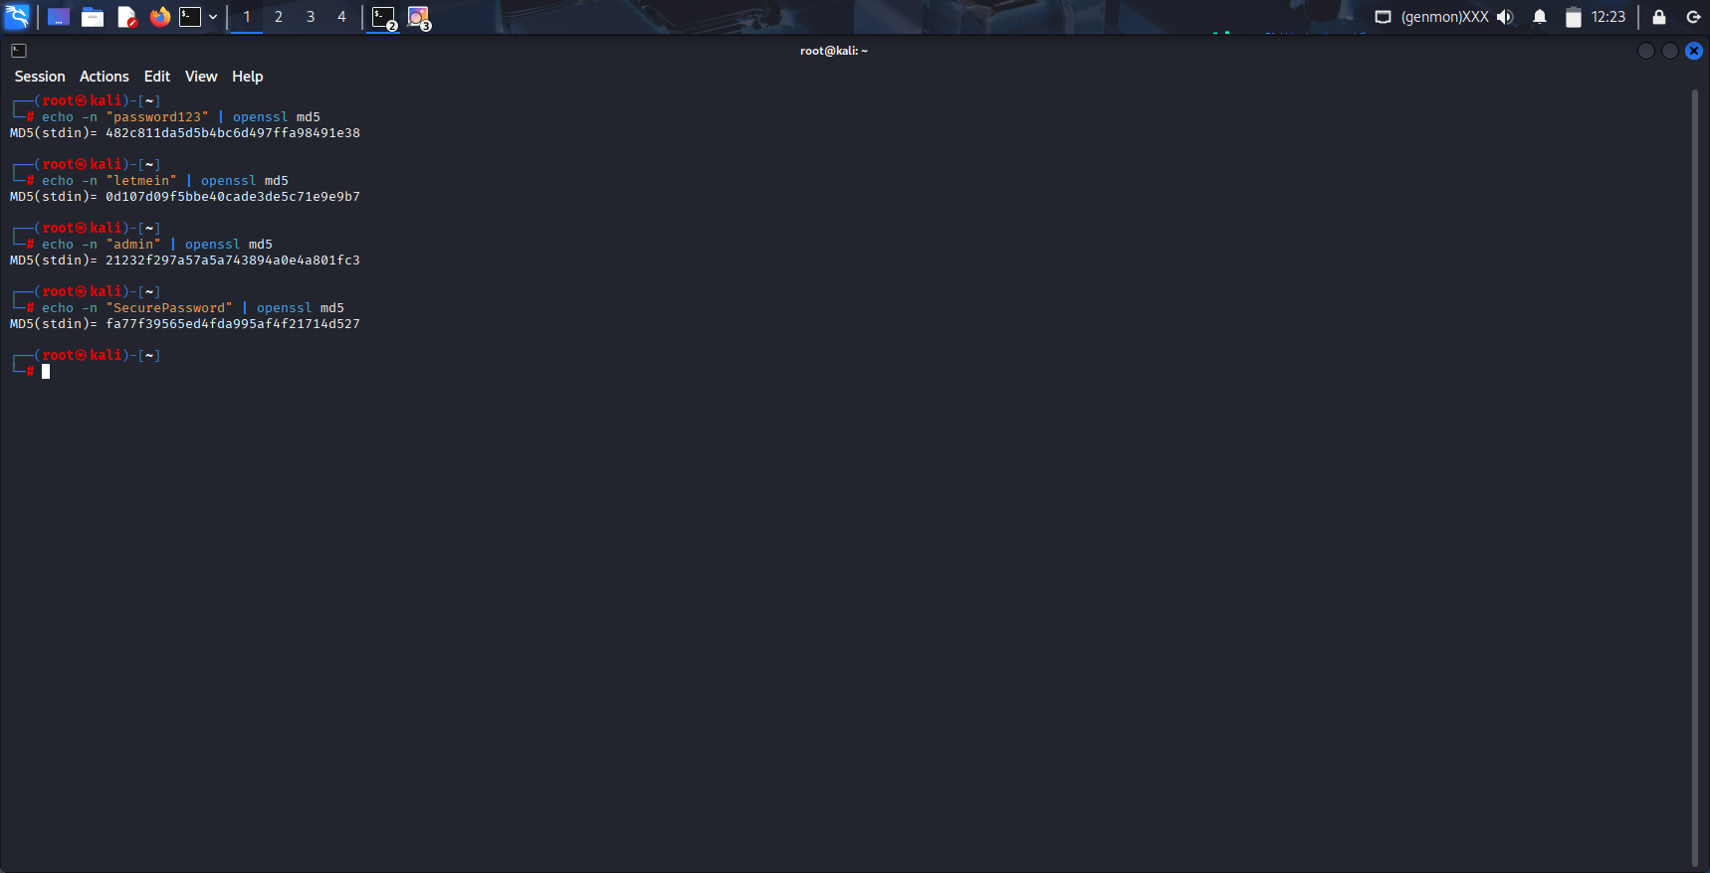
Fig. 3: MD5 hashes are generated using above commands
Part 3: Create the Hashes File
You are creating a new text file named hashes.txt and pasting the hashes you just generated into it, formatting them with a username.
1.Open the nano text editor to create the file:
Command: nano hashes.txt
2.Copy and paste the hash values from your output into the file.
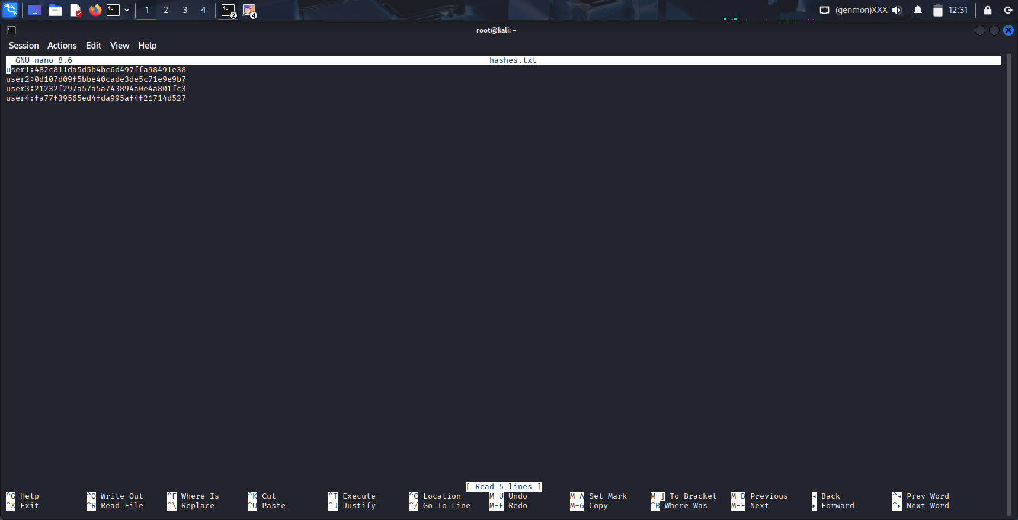
Fig. 4: Entering the hash values in hashes.txt file
3.Save the file:
  - Press Ctrl + O (Write Out)
  - Press Enter to confirm the filename (hashes.txt)
  - Press Ctrl + X to exit nano
You have now successfully created the target for your password cracking challenge. You have a file containing four password hashes: three weak ones that should be easily cracked, and one strong one that should resist the attack.
Step 3: Execute the Dictionary Attack
You are running the john command, instructing it to use a specific wordlist (rockyou.txt) to try to crack the MD5 hashes stored in your hashes.txt file. This is known as a dictionary attack.
Why is this important?
- The Attack Method: A dictionary attack is one of the most common and effective password cracking techniques. It doesn't try every possible combination (brute force) but instead tries a list of the most likely passwords. This makes it incredibly fast against weak passwords.
- Simulating a Real Attack: This is exactly what a real attacker would do after stealing a database of hashed passwords. They would use a large wordlist to quickly find any users with simple, common passwords.
- The --format Flag: This is a critical part of the command. It tells John the Ripper exactly which type of cryptographic hash it is trying to crack. If you don't specify the format, John will try to auto-detect it, which can sometimes fail. By using --format=Raw-MD5, you are ensuring John uses the correct method to hash each word from the list before comparing it to your targets.
Here is the command to run,
john --wordlist=/usr/share/wordlists/rockyou.txt --format=Raw-MD5 hashes.txt
- john: This calls the John the Ripper program.
- --wordlist=/usr/share/wordlists/rockyou.txt: This is the --wordlist flag (you can also use --wordlist=). It tells John the location of the file containing the list of passwords to try.
- --format=Raw-MD5: This is the --format flag. It explicitly tells John that the hashes in the target file are standard MD5 hashes.
- hashes.txt: This is the final argument. It tells John which file contains the target hashes you want to crack.

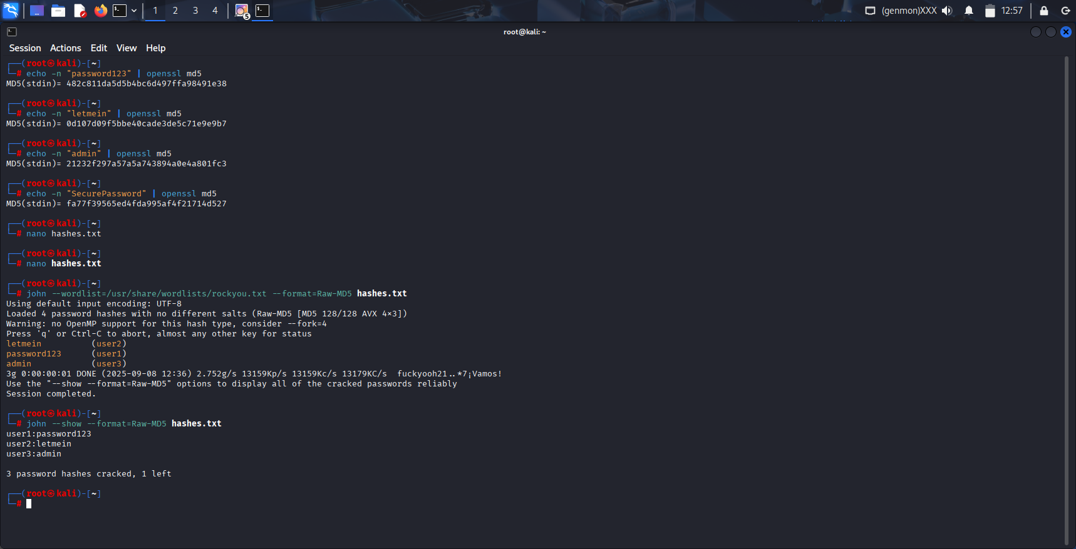
Fig. 5: Executing dictionary attack
Step 4: View the Results
This step is where you see the payoff of the cracking process. After running John the Ripper, it stores the cracked passwords in a special file. The --show command is used to retrieve and display these results in a clear, readable format.
To See the Final Results Clearly
john --show --format=Raw-MD5 hashes.txt
Here is a breakdown of what each part does:
- john: The main command to run the John the Ripper program.
- --show: This is the "show results" flag. It tells John to read its database of cracked passwords and print them to the screen in a readable format. It does not perform a new cracking attempt.
- --format=Raw-MD5: This option specifies the hashing algorithm used on the passwords you want to see.
- Raw-MD5 means the passwords were hashed using the standard MD5 algorithm (without any salt). This is a crucial piece of information John needs to correctly match the hashes to the cracked passwords.
- hashes.txt: This is the input file that contains the list of password hashes you originally asked John to crack. The --show command uses this file to display the hashes alongside their cracked plaintext passwords.

Fig. 6: Finall results by using john --show --format=Raw-MD5 hashes.txt
- The List: The first three lines show the successful cracks. Each line follows the username:password format that was in your original file, but now the hash has been reversed to reveal the original plaintext password.
  - user1: password123
  - user2: letmein
  - user3: admin
- The Summary: The final line is a crucial summary of your entire experiment:
- 3 password hashes cracked: This confirms that three of the four passwords were weak enough to be found in the rockyou.txt wordlist. This is the evidence of the vulnerability.
- 1 left: This confirms that one password (SecureP@ssw0rd! for user4) was strong enough to resist the dictionary attack. It remains secure and "uncracked."
The output of the --show command is the primary result you will discuss in your report's conclusion, as it clearly demonstrates the difference between weak and strong passwords.
Step 5: Attempt a Brute-Force Attack
This optional step is a powerful demonstration that goes beyond the initial dictionary attack. It shows the fundamental difference between cracking weak passwords and strong ones.
You are instructing John the Ripper to use its Incremental Mode to attempt a brute-force attack on the one remaining uncracked hash in your hashes.txt file. This mode tries every single possible combination of characters, in order of increasing complexity, until it finds the password or you stop it.
Why is this important?
- Demonstrating Password Strength: The dictionary attack proved that weak, common passwords are easy to crack. This step proves that complex passwords are computationally infeasible to crack. It shows why "SecureP@ssw0rd!" is a good password—it's not found in any wordlist.
- Understanding the Attacker's Full Capability: A brute-force attack is the most comprehensive—and slowest—method an attacker can use. Showing that this method is impractical against a strong password is the strongest possible argument for using such passwords.
- The Trade-Off: This step visually illustrates the core trade-off in password cracking: Speed vs. Completeness. A dictionary attack is fast but incomplete. A brute-force attack is complete but incredibly slow.
Command: john --incremental --format=Raw-MD5 hashes.txt
This command is used to attempt to recover (crack) passwords from a list of cryptographic hashes stored in the file hashes.txt. It uses the John the Ripper tool, a popular password security auditing and recovery application.
Breakdown of Components:
- john: The name of the program being executed (John the Ripper).
- --incremental: The cracking mode. This is the most powerful mode, which tries all possible character combinations. It starts with short passwords (e.g., "a", "b", "1") and progressively attempts longer and more complex ones. It will run indefinitely until stopped or until all possibilities in its built-in character sets are exhausted.
- --format=Raw-MD5: Specifies the hash algorithm. This tells John that the hashes in the file are simple MD5 hashes without any salt. It is crucial to specify the correct format for the tool to work properly.
Example of a Raw MD5 Hash: 5f4dcc3b5aa765d61d8327deb882cf99
- hashes.txt: The input file. This is a text file containing the list of password hashes that you want to crack, with one hash per line.

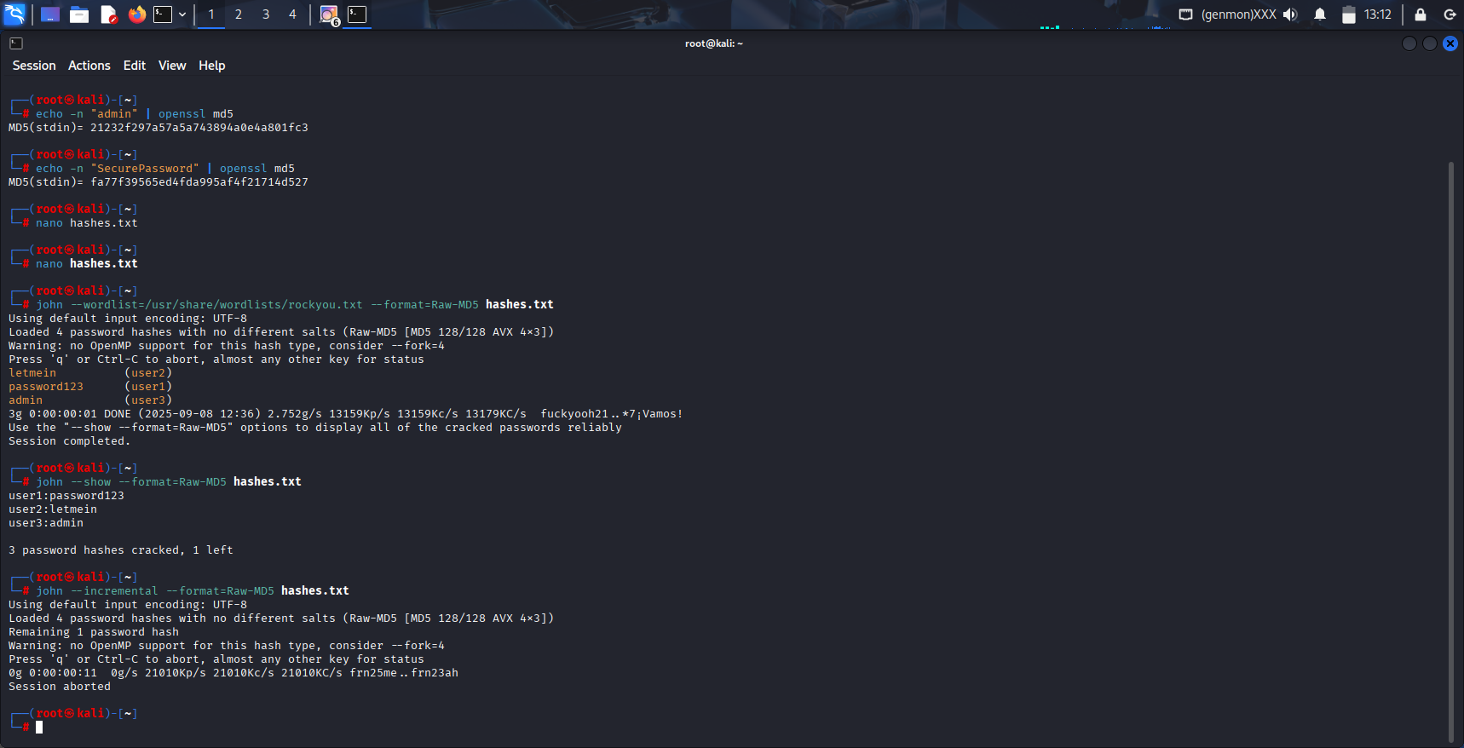
Fig. 7: password_cracking_workflow
This output clearly shows why the strong password (SecureP@ssw0rd!) remains secure. Let's break down what each line means:
- Loaded 4 password hashes... Remaining 1 password hash
  - Translation: John acknowledges all 4 original hashes but correctly identifies that only 1 is left uncracked from your previous dictionary attack. It will now focus only on that one.
- Warning: no OpenMP support... --fork=4
  - Translation: This is a technical note. It means John cannot use all of your CPU's cores (parallel processing) to crack this specific hash type (Raw-MD5) more efficiently. It's suggesting a workaround (--fork), but it's not a problem for our demonstration.
- 0g 0:00:00:11 0g/s 21010Kp/s 21010Kc/s 21010KC/s frn25me..frn23ah
  - This is the most important part of the output. It's the status line before you aborted the session.
  - 0:00:00:11: John was only running for 11 seconds.
  - 21010Kc/s: John was testing over 21 million candidate passwords per second. This shows the incredible speed of a brute-force attack against a weak algorithm like MD5.
  - frn25me..frn23ah: These are examples of the random, complex passwords John was currently trying. Notice they are nothing like simple words—they are chaotic combinations of letters and numbers.
  - Despite this massive speed, the progress (0g) was ZERO. It didn't crack the password.
- Session aborted
  - You pressed Ctrl + C to stop the process after 11 seconds.
This output is perfect evidence for your project conclusion. It demonstrates two critical things:
- The Strength of Complex Passwords: Even at a rate of 21 million guesses per second, a strong password (not based on a dictionary word) can resist a brute-force attack for an impractical amount of time (years, centuries, or longer).
- The Danger of Weak Algorithms: The speed (21 Mc/s) also shows why using a modern, slow hashing algorithm (like bcrypt) is so important. Bcrypt is intentionally designed to be slow, reducing this guess rate to only a few hundred per second, making brute-force attacks utterly useless.

Step 6: Clean Up Session
This final step is about maintaining a clean and accurate working environment for future experiments. It involves clearing the results from your current cracking session from John the Ripper's internal database.
You are using the --remove flag with John the Ripper to delete the cracked passwords for your specific hashes.txt file from its internal storage (known as the "pot file"). This does not delete your hashes.txt file; it only clears John's memory of the results.
Why is this important?
- Prevents False Results in the Future: John the Ripper stores every password it ever cracks in a single, central pot file (~/.john/john.pot). If you run John again on the same hashes.txt file without cleaning up, it will instantly display the previously cracked passwords without doing any new work. This would give you a false positive and ruin the integrity of any new testing.
- Good Lab Hygiene: It's the equivalent of wiping down your workbench after an experiment. It ensures that your next session starts fresh, with no leftover data from previous runs that could contaminate your results.
- Essential for Accurate Reporting: If you are documenting the process for a report, you need to be able to run the commands from scratch and see the actual cracking process happen. If the answers are already stored, you can't demonstrate the time it took or capture the correct output.
Command: john --format=Raw-MD5 --remove hashes.txt (or) rm ~/.john/john.pot
This command attempts to crack the passwords stored in the hashes.txt file.
- john: The main command to run the John the Ripper tool.
- --format=Raw-MD5: Tells John that the hashes in the file are simple, unsalted MD5 hashes.
- --remove: Deletes any cracked passwords from the hashes.txt file after they are found. This is useful for cleaning up the list so only uncracked hashes remain for future attempts.
- hashes.txt: The name of the file containing the list of password hashes to be cracked.
You can verify it worked by running the show command again:
Command: john --show --format=Raw-MD5 hashes.txt
This command displays the passwords that have been successfully cracked.
- --show: Instructs John to show all cracked passwords from the specified file.
- --format=Raw-MD5: Again, specifies that we are dealing with Raw MD5 hashes.
- hashes.txt: The file that was originally cracked.

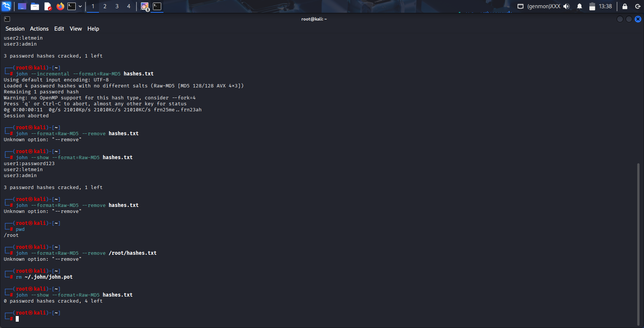
Fig. 8: wipes John's entire history of cracked passwords for all files,
This completely wipes John's entire history of cracked passwords for all files, giving you a 100% fresh start. It's the most reliable method.

Conclusion
The Password Cracking Challenge using John the Ripper successfully demonstrated the critical vulnerabilities inherent in weak password practices and outdated cryptographic hashing algorithms. Through the practical application of dictionary and brute-force attacks, the project vividly illustrated how simple, common passwords such as "password123," "letmein," and "admin" can be compromised almost instantaneously. In contrast, a strong, complex password like "SecurePassword!" effectively resisted both attack methods, underscoring the importance of password complexity and length in defending against unauthorized access.
The project also highlighted the significant role that hashing algorithms play in security. The use of MD5—a fast and cryptographically broken algorithm—allowed John the Ripper to test over 21 million password combinations per second during a brute-force attack. This alarming speed emphasizes why modern, slow hashing functions like bcrypt or Argon2 are essential: they intentionally reduce the number of guesses per second, rendering brute-force attacks economically and computationally infeasible.
Beyond technical execution, this exercise reinforced essential ethical principles in cybersecurity, such as conducting penetration tests only in controlled, authorized environments. It provided hands-on experience with industry-standard tools and methodologies, bridging theoretical knowledge with real-world applications. Ultimately, this project serves as a compelling reminder that robust password policies, continuous education, and the adoption of modern security practices are indispensable in safeguarding digital identities and assets in an increasingly threat-laden landscape.

